January 19th, 2020: 2nd Sunday of Epiphany

Plough Sunday Service: Yorkshire’s farming community was celebrated at Ripon Cathedral on Plough Sunday with the Cathedral’s traditional service. The service, held in conjunction with the Yorkshire Agricultural Society, continues a tradition dating back to the Middle Ages when the ploughs were blessed and prayers offered for God’s continuing providence.
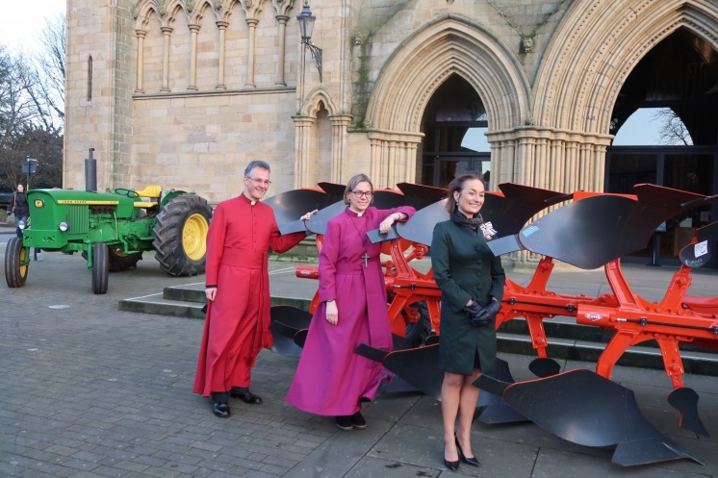
This was continued this year with Bishop Helen-Ann Hartley, Bishop of Ripon, blessing a ploughshare during the service, and was attended by some 250 people. The Lord Lieutenant of North Yorkshire, Mrs Johanna Ropner, representing Her Majesty the Queen, attended the service and also gave an address. Mrs Ropner is pictured with the Very Revd John Dobson, Dean of the Cathedral, and Bishop Helen-Ann. James Johnson, a farmer who works near Mallard Grange, just outside Ripon, also gave an address. The service was featured on BBC Look North and BBC Look North East and Cumbria and in the Yorkshire Post.

Today: The Visit of Revd Canon Derek Walmsley,
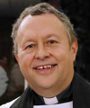
Diocesan Director of Ordinands and Vocations
We are delighted to be able to welcome Canon Derek (pictured, left) , who will be preaching at both our services today, and sharing with us something of the vocations process within our Diocese of Leeds.

From the Diocesan website vocations page.. https://www.leeds.anglican.org/vocations :

God calls everyone
We are all called
- to follow and serve Jesus Christ
- to be part of His body, the church
- to love each other and
- to care for the world in which we live.

Some people discover that God may be calling them to quite a specific ‘calling’ and this is sometimes called a ‘vocation’. Vocation means different things to different people. Some people feel called to their daily work or a particular task. In the church, Vocation is usually about God calling someone to a specific role within the church. All Christians have a calling – to love and serve God at home, work and in church roles. These are all important callings. Some people however sense they are called to a more formal and public role in the church and this is where the Vocations Team comes in.
To begin exploring what God might be calling you to, please visit the digital learning platform and sign up to information from the vocations team. This will let us contact you about things that are happening that might help you work this out and send you occasional mailings which might help you.

There are many roles you may be called to, paid and unpaid. Vicar, chaplain, youth worker, lay preacher, evangelist, joining a religious community, planting new churches (pioneer ministry) are just some. Why not take a look at our booklet about vocations to find out more about some of the things you may be called to do or be.
First - speak to your priest or vicar as they will have the best idea as to how realistic your sense of calling is.Then contact the Vocations Team, who will arrange for you to meet someone to discuss it further. Finally you might think about attending a nationally organised event to help you consider your calling further? One of these, Known and Called – is an annual autumn event at Cranmer Hall, Durham.

Forthcoming Events:
Café Church at St Mary’s with Revd Canon Dr Alan Bartlett We’re invited to go along to this month’s Café Church at St Mary’s, Richmond (4pm, 17th Feb) to hear Revd Canon Dr Alan Bartlett, Ministry Development Adviser, Diocese of Durham. Alan lectured for years at Cranmer Hall, Durham, training Anglican ordinands, and his recently published book, ‘Vicar’, has been well reviewed. He’s also a really good guy! Why not come along & hear what he has to say?

This week in the Parish:
Tues: 6-7pm Warden’s Hour, meeting room
10-12 noon Veterans & Community Art Group in the hall

Wed: 9-11.30am Drop-in St Cuthbert’s Community Hall
7pm PCC Meeting room
Thurs: 7.30pm: Prayers for the World meeting room
Fri: 1pm Funeral of Patrick Noel Meehan Presided over by Fr Michael from St Francis Xavier’s Church, Richmond
Sat: 10am Deep Cleaning morning St Cuthbert’s Church
Prayers For those seeking comfort & healing: Kayleigh, Katrina, Lisa, Glen, Stuart, Lee, Eve, Graham, Angelika, Gracie, Derek, Tricia & Pauline.
We pray for the families & friends of those who have died: Douglas Pinkney and Anthea Howells.

Next Sunday: Sunday of Epiphany: Vocation focus

St John’s – 9.30am Holy Communion
St Cuthbert’s – 11am All-age Worship

