January 26th, 2020: 3rd Sunday of Epiphany

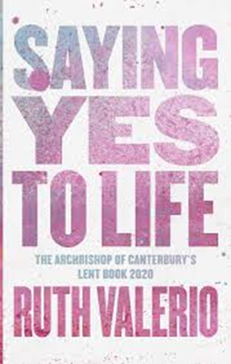
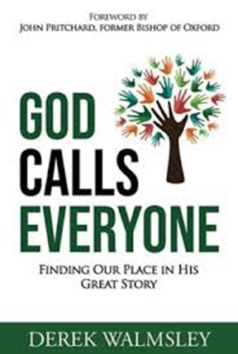
Last Sunday: The Visit of Revd Canon Derek Walmsley, Diocesan Director of Ordinands and Vocations It was great to have Derek with us at both services last week, reminding us that we all have a vocation (a calling) in God’s service. For most of us, that will be to live out our Christian lives as lay people, and for a very few it will mean a call to being trained to live and serve as ordained priests. No calling is superior to any other. We are all invited to allow our lives to be a living witness to the power of Jesus to transform us. Whatever we do, Jesus longs for us to allow him consciously to be a part of that; and promises us the love and strength to stand & serve him, through the Holy Spirit’s enabling. Derek has written a book, shown here, which is being released in April. This reinforces his point, and includes many stories of God’s calling on individual lives, and the impact of their responses. It might just be worth getting hold of an actual copy, or even a Kindle one. So, as we start this New Year, and as we were renewing our Baptismal Promises two weeks ago, maybe now is the time to re-visit those conversations with God? Where do I see you at work in my day-to-day life? What am I being called to become? How do I start to explore ideas? Maybe registering with Leeds Diocese’ Digital Learning Platform could be a good place to start? There you’ll find information on materials, courses & learning communities.

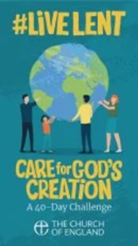
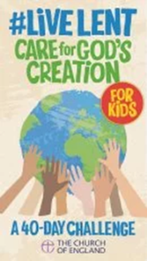
Lent Resources: The Church of England is finally acknowledging that followers of Jesus Christ really need to understand the vital issues surrounding climate change and environmental protection. As we have recently witnessed almost unprecedented forest fires in New South Wales and desperate flooding in Jakarta – while vast tracts of the Amazon rainforest are going the way of those in Borneo and Sumatra – it is becoming clear that unless something radical is done soon, we may destroy much of the planet in our own lifetime. David Attenborough is about to release a full-length film outlining his suggestions for saving the planet – a film that we should perhaps all go to see? Dr Ruth Valerio, Global Advocacy and Influencing Director at Tearfund, is a respected theologian, environmentalist & social activist. Her latest book, ‘Saying Yes to Life’, is this year’s Archbishop of Canterbury’s Lent Book. It is a cracking read! It is designed to be read by individuals either alone as part of a discussion group. To be used alongside this, the Church of England has produced some thought-provoking booklets with 40 daily prayers, reflections and challenges. There are two versions – an adult- & a children’s version. We are being asked to use these through Lent. So I have ordered sufficient copies for every family to have one. They work out at about £1.50 per copy. If you would like to chip in towards it, we wouldn’t say no! We will be running a series of Lent Course sessions based on this material on Monday evenings, starting March 2nd. Please put those in your diary.

Thanks: Many thanks to those who joined Marie with the ‘deep clean’ of the hall & church at St Cuthbert’s yesterday.

NB: Next week’s Praise & Worship service is cancelled.

Forthcoming Events:
Citizens’ Advice at Tesco: Catterick, Fri 24 Jan 10am – 1pm
Free Drop-in for help with energy bills, switching suppliers, and help with any other energy issue. Free goody bags, too!

Hedge trimming.. 10.30am Sat 8th February - following on from the men’s breakfast. Equipment provided. For further information, contact Revd Andrew.

Café Church at St Mary’s with Revd Canon Dr Alan Bartlett Next month’s Café Church at St Mary’s, Richmond (4pm, 17th Feb) features Revd Canon Dr Alan Bartlett, Ministry Development Adviser, Diocese of Durham in conversation with +John Pritchard. This should be a very good afternoon.
Why not come along & hear what he has to say?

This week in the Parish:
Tues: 6-7pm Warden’s Hour, meeting room
10-12 noon Veterans & Community Art Group in the hall

Wed: 9-11.30am Drop-in St Cuthbert’s Community Hall
7.30pm Prayers for the World Meeting room

Prayers For those seeking comfort & healing: Lisa, Glen, Stuart, Lee, Eve, Graham, Angelika, Gracie, Derek, Tricia, Ann, Jenny & Pauline.
We pray for the families & friends of those who have died: Douglas Pinkney, Anthea Howells and Noel Meehan.

Next Sunday: Presentation of Christ at the Temple

St John’s – 9.30am Service of the Word
St Cuthbert’s – 11am Holy Communion + KFC
Please note: No 6.30pm evening Praise & Worship service

